**Milestone 4: Bacchus Case Study [Solution]**

**Group Introduction:**

* We are “*Dev-Tools*” !
* A team dedicated to solving the business challenges that Bacchus is currently experiencing through data management solutions.
* There are a total of two team members associated with our group:
* Vincent Ryan: Monday-Friday (6:30 PM - 8:30 PM CST)
* Paul Singleton: Monday-Friday (6:30 PM - 8:30 PM CST)

**Case Study Description / Overview:**

* The Bacchus Case Study is in need of a solution that manages the company’s wine sales, inventory, suppliers, and employees more effectively.
* Therefore, we came up with a solution that solves the current dilemmas experienced and provides an easy way to generate reports based on the information already found in their systems.
* The goal was to combine various tables into unique identifiers, so that we could pull commonly used information into different views.

**Finalized ERD:**

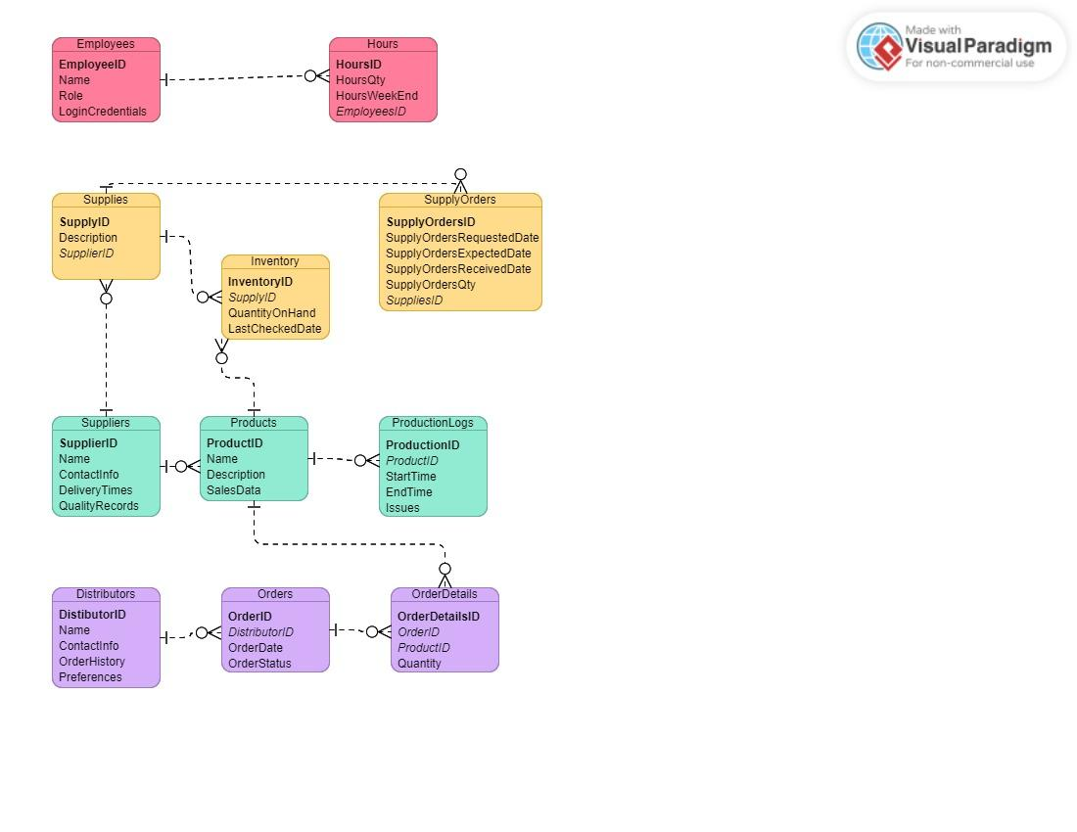

**Description of Reports Generated:**

* **Wine Sales Report:**

- Shows information on the total sales of each wine type.

* **Distributor Orders Report:**

- Logs the orders placed by each distributor, which is grouped by wine type.

* **Employee Work Hours Report:**

- Produces the total hours worked by each employee over the last four quarters.

* **Late Supply Orders Report:**

- Lists the supply orders that were received later than the anticipated delivery date.

* **Pending Supply Orders Report:**

- Shows the supply orders that haven’t currently been received.

**Generated Reports - Results:**

1. **Wine Sales Report - (Output):**

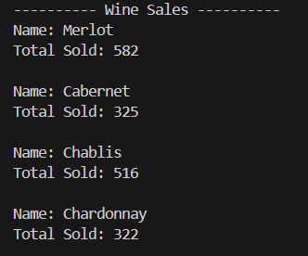

1. **Distributor Orders Report - (Output):**

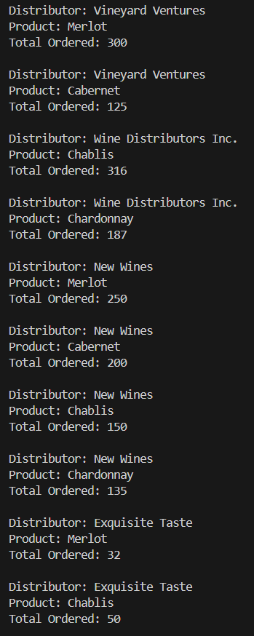

1. **Employee Work Hours Report - (Output):**

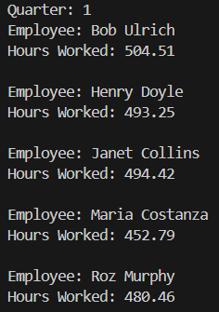

1. **Late Supply Orders Report - (Output):**

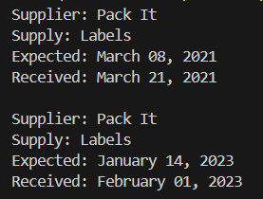

1. **Pending Supply Orders Report - (Output):**

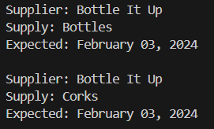

**Assumptions that led to business design:**

1. **System Integration:**

* The new system will integrate “smoothly” into Bacchus Winery’s current IT framework without any type of disruption.

1. **Staff Training and Utilization:**

* All staff and distributors will be accustomed to the new changes based on existing resources and tools.

1. **Data Transfer:**

* Historical data on inventory, sales, and employee performance will be transferred to the new system to keep tracking and reporting easy.